TEAM BUILDING PACKAGES

In this pack you will find everything you need to create the perfect event. From meetings, venue hire, team challenges and Office Master Chef cook-offs… we’ve got it covered!

Our funky warehouse cooking school is the perfect place to have your next event.

Our packages can be tailored to your requirements and wish lists so please do not hesitate to contact us for any enquiries and bookings.
Happy Cooking!
The Vanilla Zulu Team

TABLE OF CONTENTS

OVERVIEW 3
MASTER CHEF TEAM CHALLENGE 4
MASTER CHEF & TEAM BUILDING MENU IDEAS 5
AMAZING RACE CULINARY ADVENTURE 6
MEETINGS WITH A TWIST 7
Breakfast meetings 7
Lunch/afternoon Meetings 7
MOBILE COOKING CLASSES 8
ROOM HIRE & OPTIONAL EXTRAS 9
Meeting Room only 9
Optional Extras 9
Hot or Cold Platters 10
TERMS & CONDITIONS 11
CONFIRMATIONS 11
CANCELLATIONS 11
CATERING 11
MINORS 11
DAMAGES 11
HEALTH & SAFETY 11

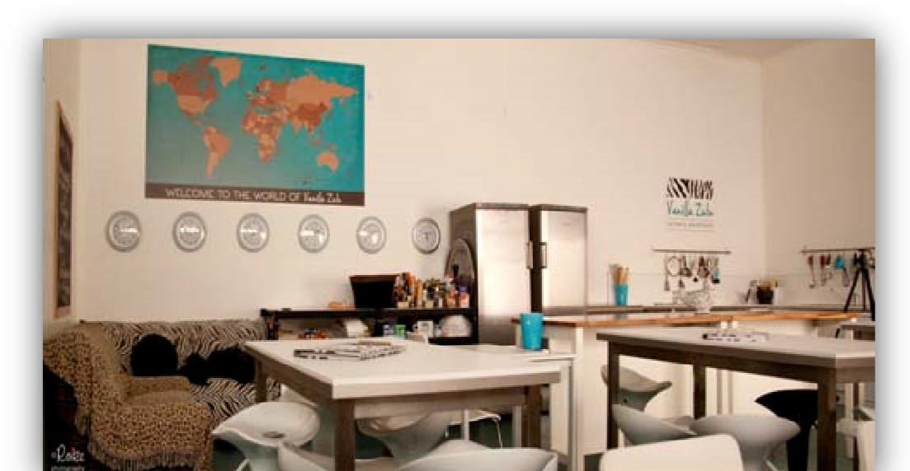
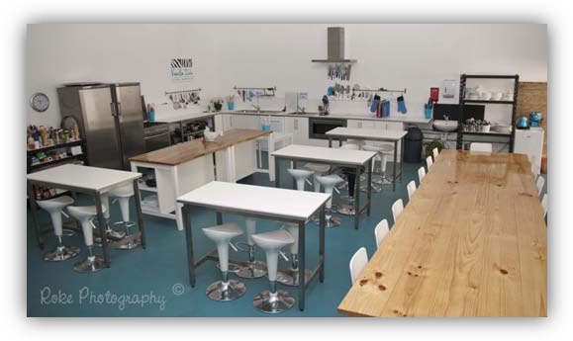
OVERVIEW
Ignite your company’s team spirit with an interactive cooking session, full of fun and laughter.

Our culinary team building events are perfect for all team-building requirements. Whether you need to entertain clients or a board of company directors, motivate employees & celebrate achievements, inspire executives, welcome new recruits or just let off steam, you will participate in an unforgettable cooking experience that will become serious water cooler chatter for your workplace!

Our interactive team building events will help your team discover hidden talents by inspiring the most reluctant of chefs in a relaxed and unintimidating environment, while interacting on a social level.
We help you create a wonderful ‘event’ for your team to look forward to! It’s a fantastic buzz around the office as team members compare recipes, notes, failures and successes between them.

These events are highly successful among both small and large companies. Your event can be tailored to best suit your needs and we are very accommodating of suggestions to make your event one to remember.

The venue is fully equipped for all your meeting requirements, including:
- White board and projector
- Internet access
- Sound system

We are able to cater for up to 30 people at Vanilla Zulu and we have access to a range of wonderful alternate venues to cater for larger groups or we can come to you.

Conveniently located in Wilston Village, Vanilla Zulu is extremely accessible, being only 5km north of Brisbane’s CBD and 1.4km from the Clem 7 Tunnel. Should you require public transport, Vanilla Zulu is also within 400m of the Wilston railway station.

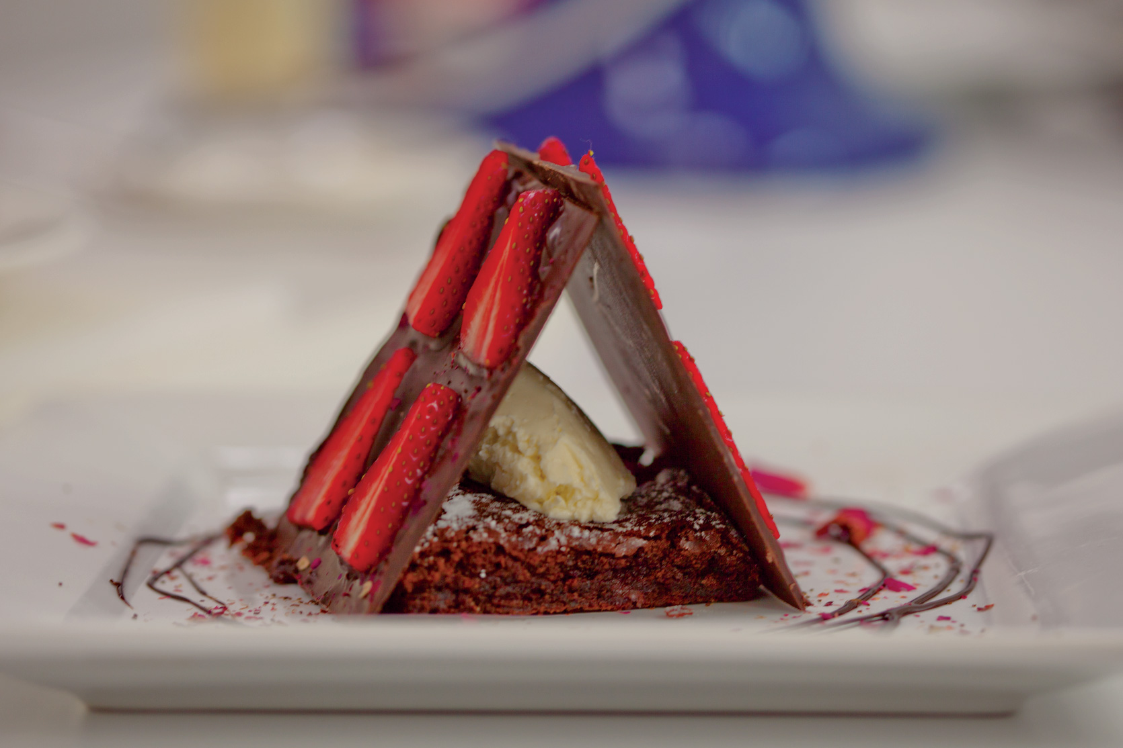

MASTER CHEF TEAM CHALLENGE
Minimum 8 people, Maximum 30 – (Up to 4 hours). All day option is an additional charge. (An offsite venue available for larger groups.

01 – 10: $140 per head.
10 – 20: $130 per head
20– 30: $120 per head

How it works:
- Teams are divided into 2 or more groups (eg: Sales vs Admin vs Marketing)
- Your Chef will coach the team leaders on how to prepare, cook and present the dish
- The timer will start and your Chef will be on hand to assist and guide the team
- The dishes can be judged based on Flavour, Presentation, timing & Team Work.
- Top Chef Awards for the ‘stand out’ Leaders or create your own fun awards using our template
- Indulge in a delectable three course meal with BYO…the perfect end to the perfect challenge

We find this is a really fun way to create some healthy competition, allows management to see leadership styles within the team and creates a great environment for colleagues to bond, or just rewards a team and allows them to have a little bit of fun whilst learning valuable culinary skills.

The menu can be themed and we offer many options that can be personalized or changed as per your request. Most sessions are three hours and the best part is that you will enjoy a wonderful three course meal that you have all cooked together!

Option - Hold a workshop in the morning including morning tea, break for a light lunch and then spend the afternoon enjoying the Master Chef Challenge (Additional charges apply, contact us for more info)

*Packages and menus can be tailored to suit specific needs so please let us know your requirements
** See Pages 9/10 for optional extras

MASTER CHEF & TEAM BUILDING MENU IDEAS
Here are some examples other companies have used for their event:
- Around the world in three hours (feasts from around the world)
- Mystery Box – let’s get creative and think out the box
- Desserts and Pastries
- Eat yourself sexy menus
- Modern Thai Fusion
- Girls vs Boys Cook Off Challenge – Who rules the kitchen??
- Store against store – eg: Brisbane vs Gold Coast
- Kitchen warriors – seriously competitive
- A taste of Tuscany – glorious sun food
- A taste of the Mediterranean
- Mystical Middle East – Make your pork belly dance!
- Death by chocolate platter – chocolate decadence
- Or any other country cuisine of your choice – Spanish Tapas, Mexican or Cuban Fiesta … you decide!
- Quickies in the kitchen – 1 hour express three course meal

AMAZING RACE CULINARY ADVENTURE
Add an additional twist to your event by sending your team on a Hunting & Gathering expedition. Each team will be given their menu, a budget & a time allocation of 1 hour to hunt down and gather their ingredients. They must use their money and time wisely & adjust the quantities accordingly to suit the number of people in their team. The real key to this is TEAM WORK! (Additional charges may apply)

Vanilla Zulu pride ourselves on taking you on a Culinary Adventure, each and every time…Be it Amazing Race or a Master Chef Challenge, we have it covered! Our team are adventurous, creative and happy to take your ideas and make it happen so your event is one they will be talking about fondly for a long time.
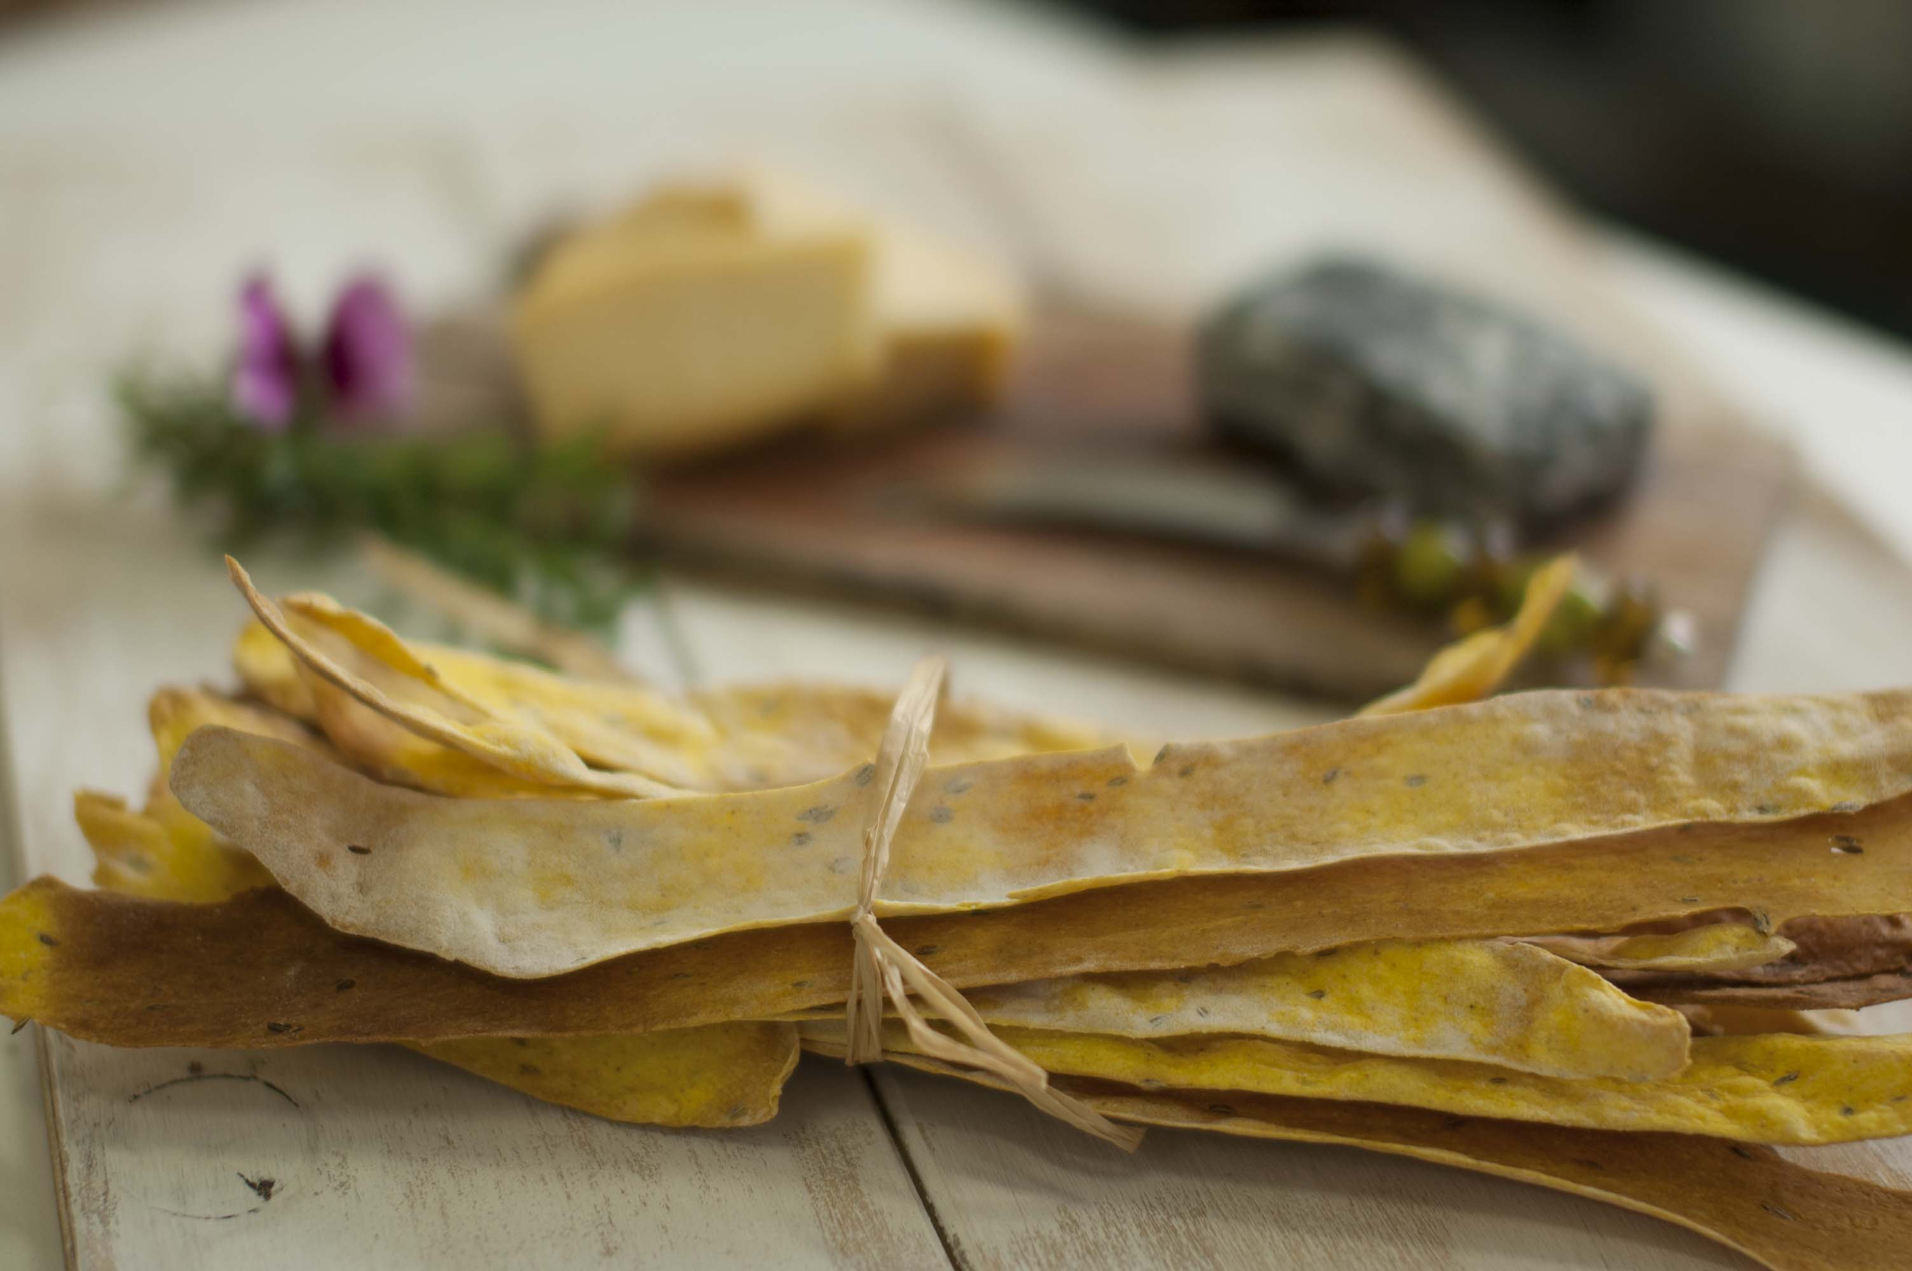
MEETINGS WITH A TWIST

Breakfast meetings
Let us help you spice up your morning team or sales meeting. Go on a Vanilla Zulu Culinary Adventure!

Package 1: $750 for up to 4 hours room use – maximum 10 people
Includes
- 1 hour interactive cooking demo with our chef! Hot breakfast buffet supplied, have a mini master chef challenge! (Healthy choice breakfast option available on request)
- Unlimited coffee and tea.
- Use of white board, projector, wireless data & sound system

Package 2: $1250 for up to 4 hours room use - maximum 20 people – includes as above
Package 3: $1650 for up to 4 hours room use - maximum 30 people – includes as above

*Packages and menus can be tailored to suit specific needs so please let us know your requirements

Lunch/afternoon Meetings
Give your team some variety, get them excited about their next meeting! An exciting cooking class and meeting at Brisbane’s most amazing cooking school, Vanilla Zulu Culinary Adventures!

Package 1: $850 for up to 4 hours room use – maximum 10 people
- 1 hour interactive cooking demo with our chef! Two course meal supplied and have a mini master chef challenge! (Healthy choice option available on request)
- Unlimited coffee and tea.
- Use of white board, projector, wireless data & sound system

Package 2: $1450 for up to 4 hours room use - maximum 20 people – includes as above Package 3: $1850 for up to 30 people room use -maximum 30 people – includes as above

*Packages and menus can be tailored to suit specific needs so please let us know your requirements

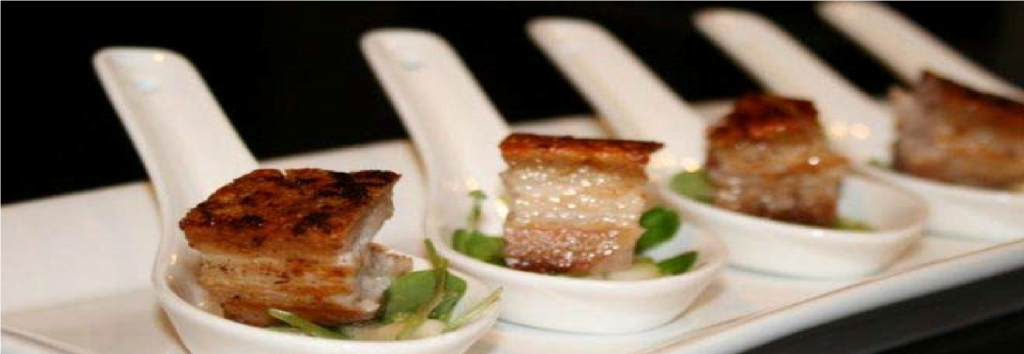

MOBILE COOKING CLASSES

Don’t have the time or the money to leave the office for your meeting but STILL want some cooking fun? Vanilla Zulu will send a highly skilled and entertaining chef to your office and do a hands-on cooking demo with your staff! Yes, we will come to you!

We would need use of your board room or staff kitchen with enough space for your group. The food will be brought in pre- prepared and what was involved. Each staff member will assemble their own plate of food -prepared however our Chef will provide all the information on how it with a prize for best plating techniques, under guidance of the chef. The team can then enjoy the feast they have helped prepare!
Class runs for 1 hour and can be extended if preferred. Cutlery and plates provided. You will required to provide your own beverages.
We have a wide variety of menus and options to choose from. Lunches & dinners (please advise if family friendly options are preferred)
Prices start from around $49 per head for a minimum of ten staff members and these events available day times only. Enquire today!
Suggested Menu’s & Themes
- Breakfast & Lunch ideas for busy people
- Cooking in bulk – but flavour infused
- Healthy options for busy people (please advise if family friendly options are preferred) Tasty on a budget
- Suggest your own theme or menu (price on application)

*Packages and menus can be tailored to suit specific needs so please let us know your requirements
** See Page 7 for optional extras

ROOM HIRE & OPTIONAL EXTRAS

Meeting Room only
- Mix it up and hire Vanilla Zulu as a meeting room only
- Room hire charge is based on an hourly rate
- Minimum 2 hours - $200 (2 hours) and $69 per hour there after
- Use of white board, projector, wireless data & sound system at no extra charge Subject to availability

Optional Extras
- Add platters to any event as per below
- Vanilla Zulu apron with your company name embroidered - $35 each
- Jar of gourmet salts as a momento to each participant - $8 each
- Paring knife for each guest or contestant $10
- Beautifully packaged Gourmet Starter Set includes a Paring knife, Blow Torch, Balsamic Vinegar Glaze, Scented Olive Oil, and one of my Mel’s signature Sexy Salts RRP $75 our price $49

Hot or Cold Platters
If all of that brain-storming gets you peckish, you can pre order one of our Gourmet platters prepared by one of our fabulous chefs. Each platter serves 10 (2 – 3 pieces per head).

Skewer platter - $85
- Cheese board with sexy water biscuits – Small $45 Large $120
- Premium sexy filled baguette/sourdough platter - $120
- Trio of Dips with crusty bread - $75
- Fruit platter – Large $75
- Death by chocolate dessert plate - $95
- Asian platter - $120
- Seafood platter - $175
- Tapas platter - $155
- Antipasto platter - $155

TERMS & CONDITIONS

CONFIRMATIONS
Once a booking is made, a $200 booking deposit non-refundable. Bookings remain tentative until the function confirmation payment authorization is s required within 5 working days. This amount is filled out and the deposit made. If the form is not returned and payment not received within the 5 day grace period the venue has the right to forfeit the booking.

CANCELLATIONS
Cancellations must be sent by email or post in writing. If a booking is cancelled within 30 days of the booked date the agreed minimum charge will be automatically charged or forfeited.

CATERING
Final numbers must be advised 7 days prior to a booking date and paid in full 5 days prior to booking date. Vanilla Zulu is licensed as a BYO venue therefore legally we are unable to sell alcohol. However there is a bottle shop 50 meters from the school and you are welcome to bring your own.

MINORS
Minors are permitted to attend however are charged per head pricing and must be accompanied by a full paying adult.

DAMAGES
While hosting or setting up a function, the customer is held responsible for any property damage that may occur throughout the duration of the event. When signing the payment authorization form the customer is agreeing to take full responsibility for any damage that occurs due to negligence or vandalism.

HEALTH & SAFETY
Please wear closed shoes or you will not be allowed to handle knives or be involved with any cooking that requires flame and high heat. Washing hands is imperative in our kitchen for obvious reasons.

NAME: ____________________________ NUMBER: _____________________________
EMAIL:_____________________________________________________________________________
ADDRESS:__________________________________________________
EVENT DATE ____________________ EVENT NAME: ____________________________
NOMINATED AMOUNT TO BE CHARGED TO CREDIT CARD: _________________________________

Card Type: VISA / MASTERCARD / (Direct Deposit – please email us for details)
CARD NUMBER: ____________________________________________________________
EXPIRY DATE: ____________________________________CCV NUMBER: _________________
NAME OF CARDHOLDER: ______________________________

By signing the document below, I hereby permit Vanilla Zulu Culinary Adventures to withdraw the nominated amount from my credit card details provided. I understand that my credit card details will be held on file until the completion of my event. I agree for Vanilla Zulu Culinary Adventures to settle any outstanding catering/hire payment prior to my function using the above credit card details. I understand that I must make the venue aware if a different credit card wishes to be used. Importantly, I if any damage vandalism or theft occur during my event due to the negligence or misconduct of my guests, the above credit card details will be used to cover all repair or insurance costs.
I agree to all the terms and conditions outlined above and in the functions package and would like to confirm my event booking.

TO BE COMPLETED BY CARDHOLDER:

SIGNATURE:____________________________________________________________
NAME:________________________________________________________________

